CaseManagement_CreationOfCase_Instance23_06-Aug-2018_03-16-42_AM_SingleSignOn.png

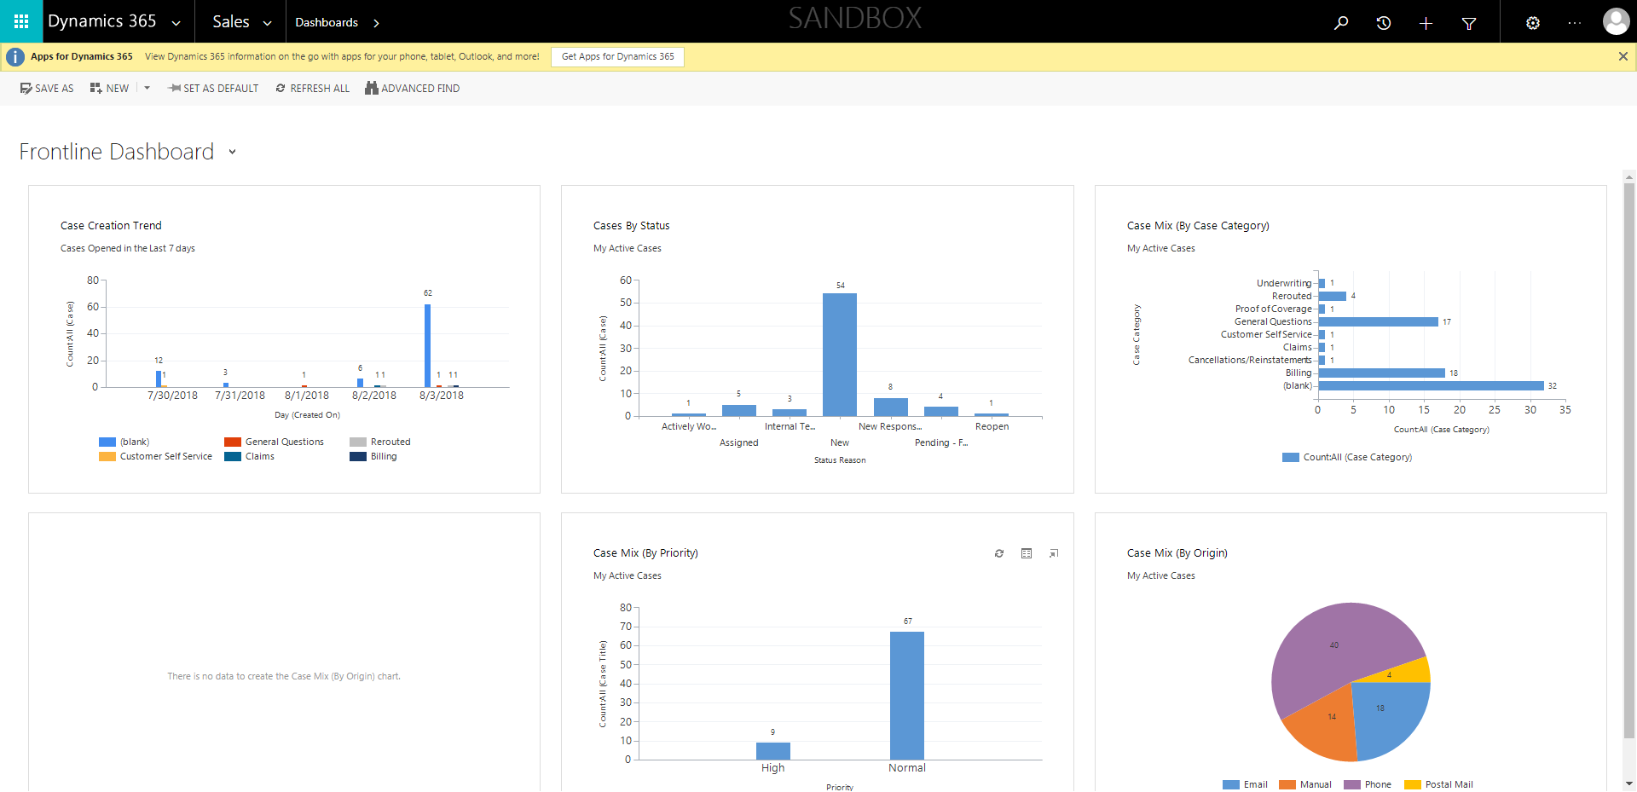

CaseManagement_CreationOfCase_Instance23_06-Aug-2018_03-17-04_AM_MouseClickActionMoveToElementBycssSelectorspanTabCS.png

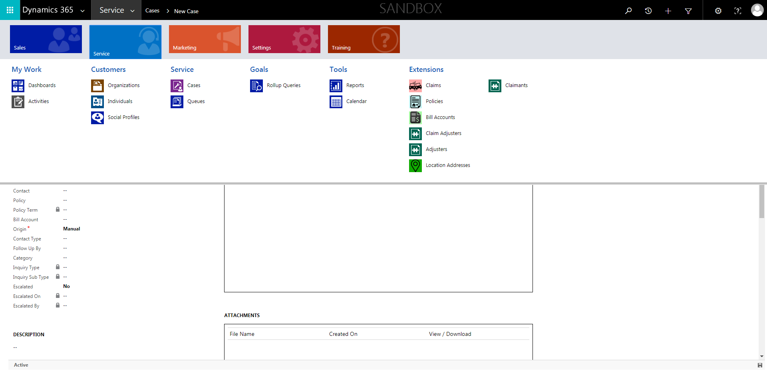

CaseManagement_CreationOfCase_Instance23_06-Aug-2018_03-16-29_AM_SingleSignOn.png

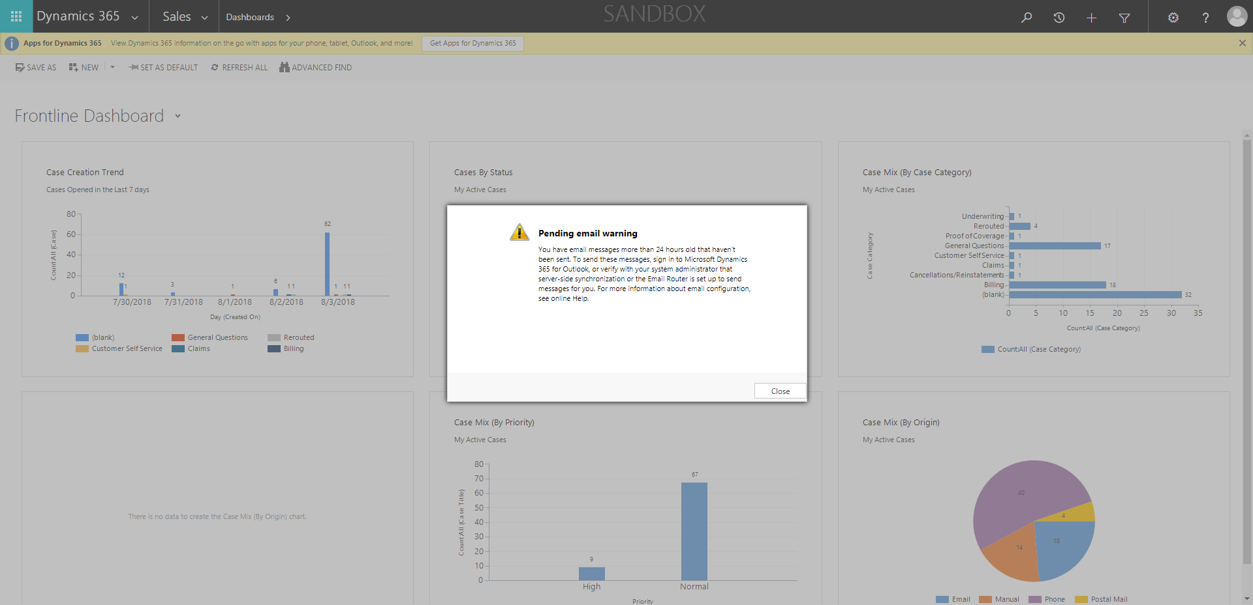

CaseManagement_CreationOfCase_Instance23_06-Aug-2018_03-16-06_AM_MouseClickActiononStaleElement.png

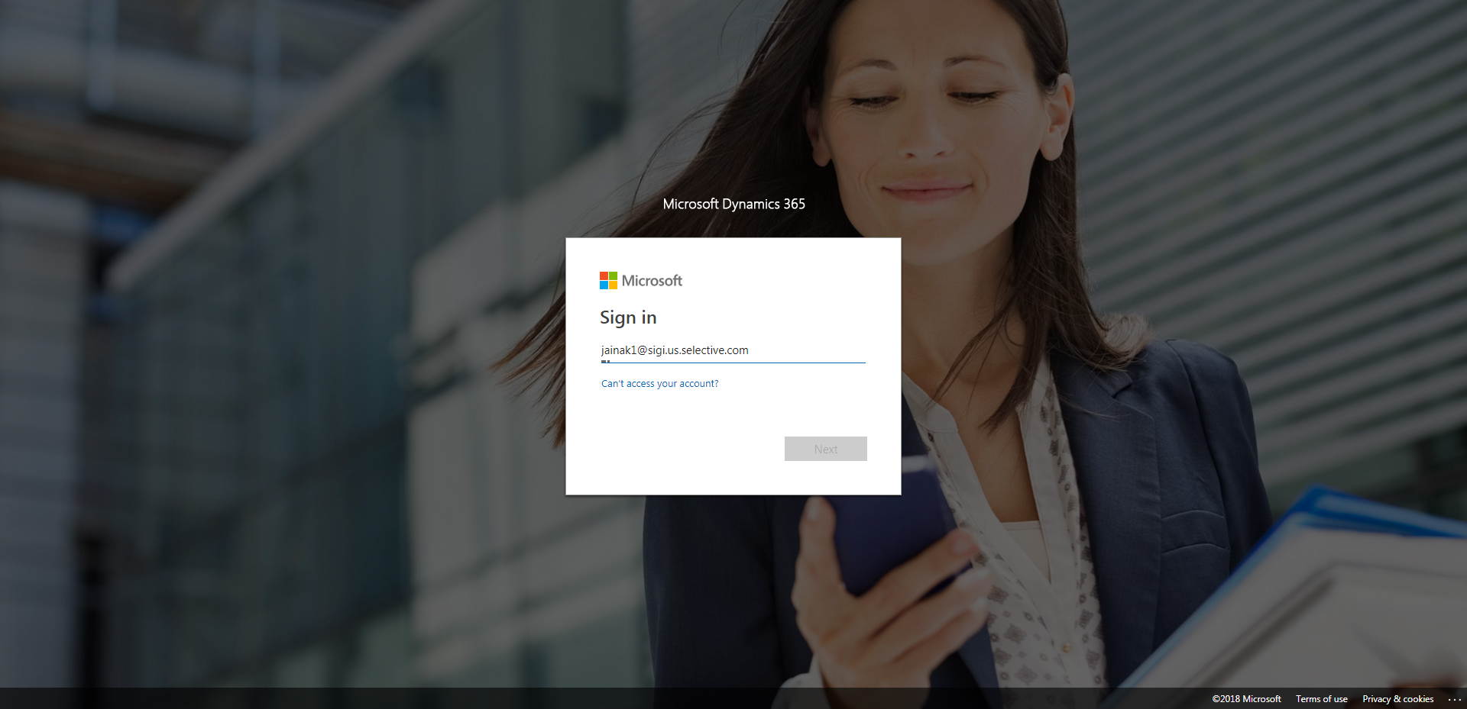

CaseManagement_CreationOfCase_Instance23_06-Aug-2018_03-16-03_AM_MouseClickActiononStaleElement.png

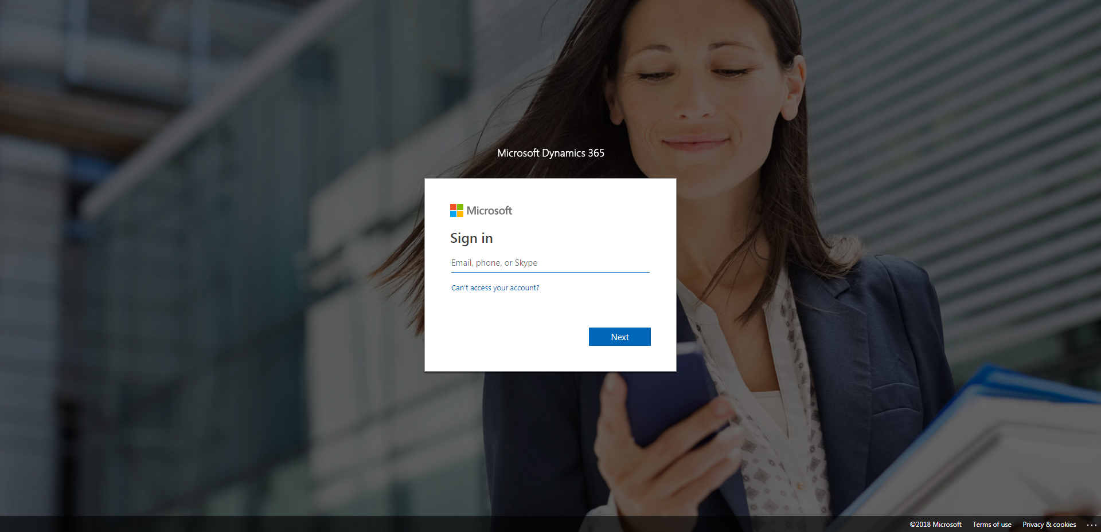

CaseManagement_CreationOfCase_Instance23_06-Aug-2018_03-16-48_AM_MouseClickActionMoveToElementByxpathimgaltServiceparentspan.png

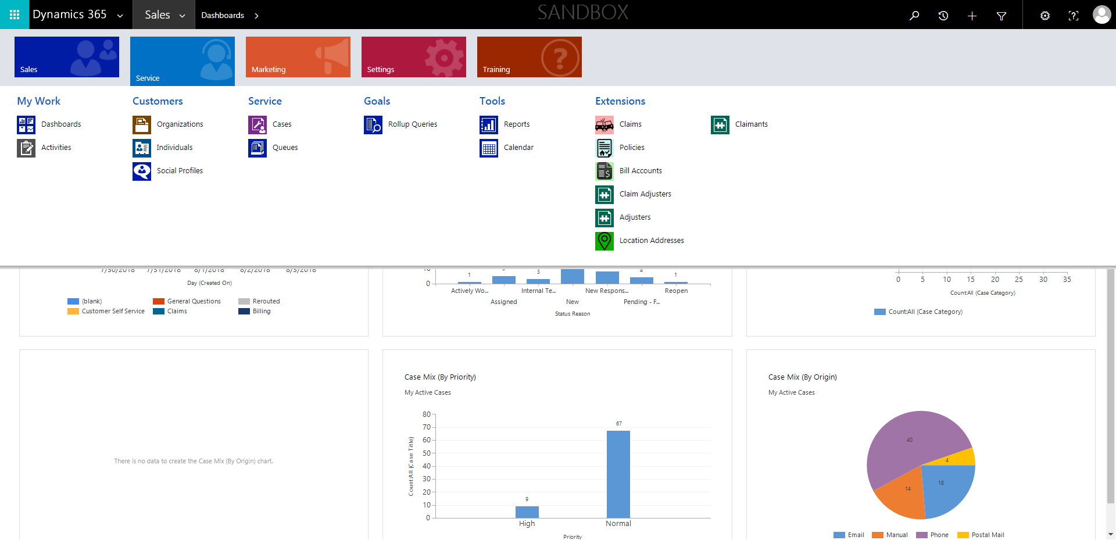

CaseManagement_CreationOfCase_Instance23_06-Aug-2018_03-16-49_AM_MouseClickActionMoveToElementBycssSelectoranavcases.png

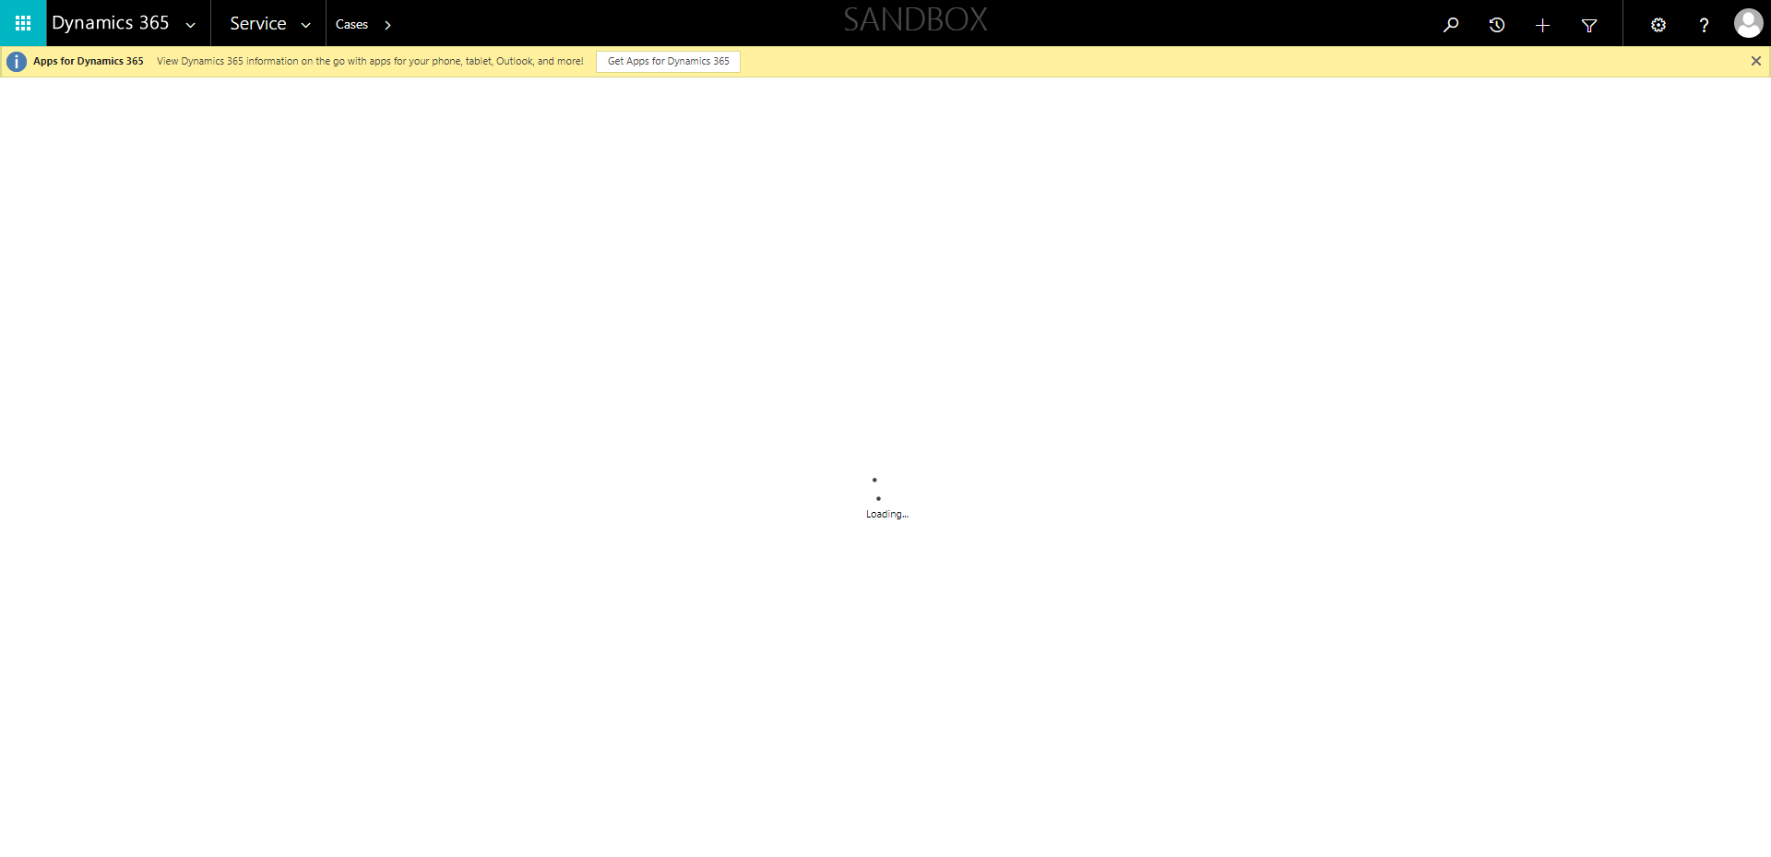

CaseManagement_CreationOfCase_Instance23_06-Aug-2018_03-17-04_AM_MouseClickActionMoveToElementByxpathimgaltServiceparentspan.png

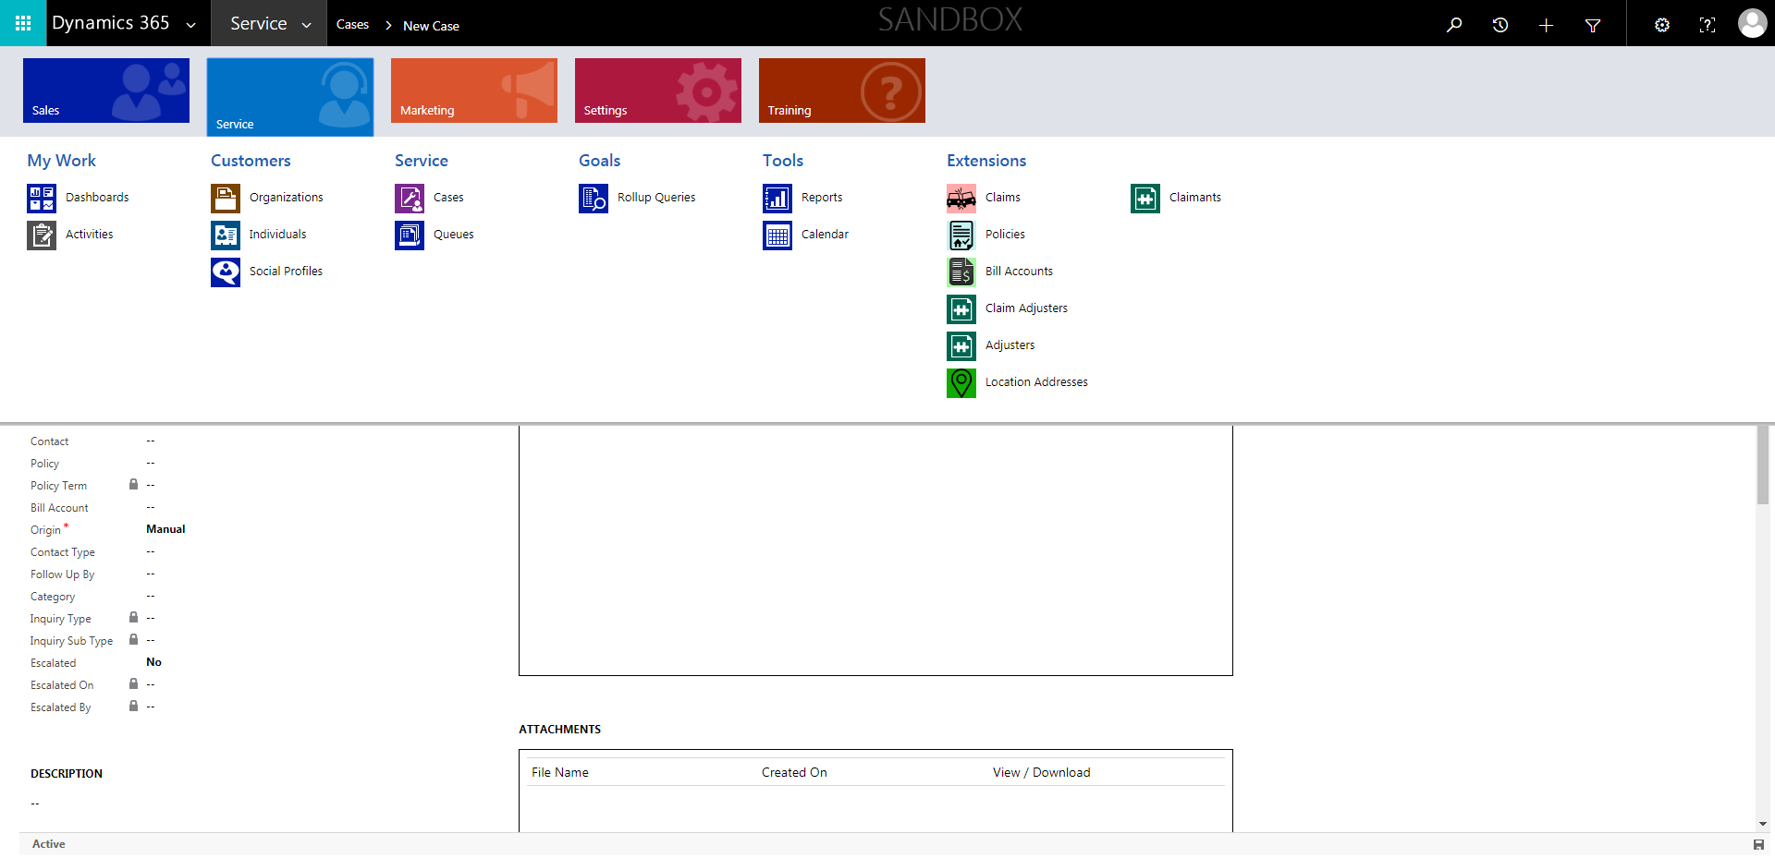

CaseManagement_CreationOfCase_Instance23_06-Aug-2018_03-16-46_AM_MouseClickActionMoveToElementBycssSelectorspanTabSFA.png

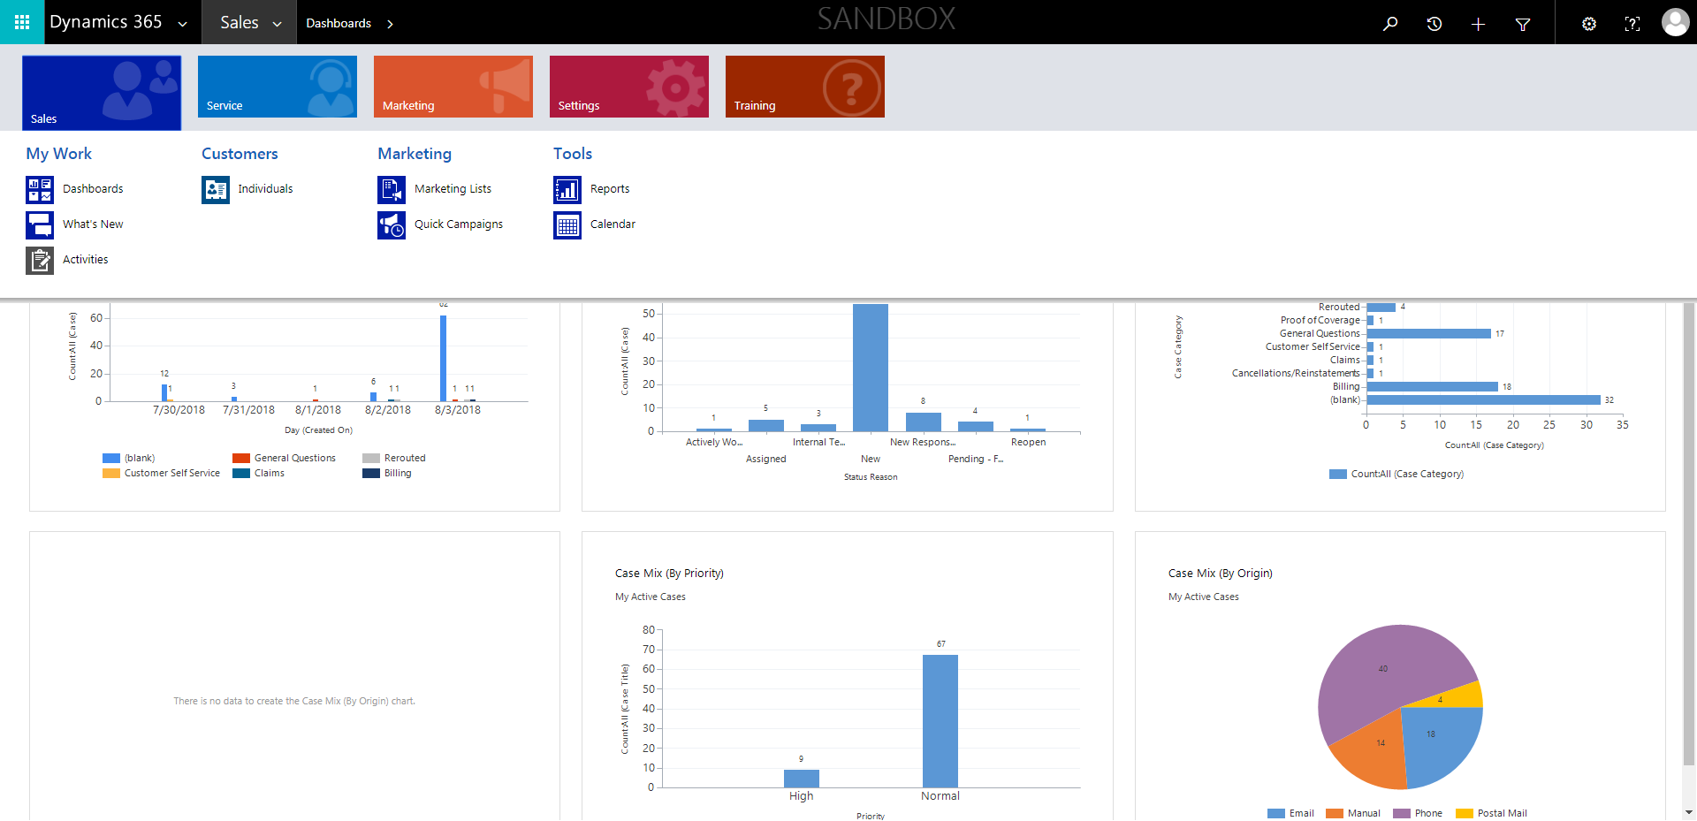

CaseManagement_CreationOfCase_Instance23_06-Aug-2018_03-16-04_AM_EnterTextAction.png

